Set these little critters on an incline and watch them cartwheel a beeline to the bottom. The secret to their antics is a marble rolling around inside.
Materials
- Scissors
- Card stock
- 2 nickels
- Tacky glue
- Toothpick
- Marble (1 for each bug)
- Black marker
- Colored tissue paper
- Glue stick
X
Instructions
- 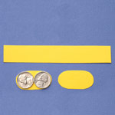For each bug, cut a 5-1/2- by 3/4-inch strip of card stock and two 1 3/4- by 7/8-inch card stock ovals.
- 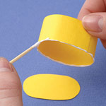To make an oval, lay 2 nickels side by side on the card stock and trace around them, connecting the top and bottom.
- 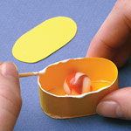Glue the strip into a loop, overlapping the ends by an inch. Pinch it or use a paper clip to hold it together while the glue dries.
Next, use a toothpick to line one edge of the loop with glue, then set the loop on top of an oval.
- 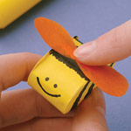When the glue dries, place a marble inside. Line the edge of the loop with glue and press the other oval on top.
- 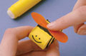Once all the glue is dry, use a marker to add a face and other features. Cut out a couple of 2-inch-long wings from tissue paper and use the glue stick to attach them to the top of your bug.

